**Linux Commands: Part II**

1. **sudo su** or **su** - to switch to root user

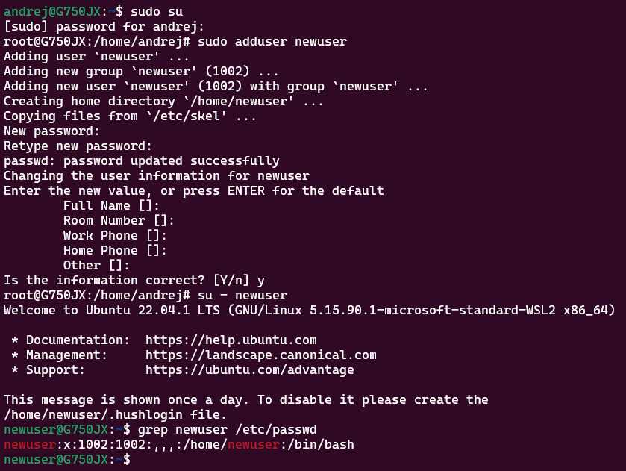

1. **sudo adduser username** to create a new user



1. **su - username** to log in as the new user



1. **grep username /etc/passwd** to check if the user is created



1. **cut -d: -f1,3 /etc/passwd** to get the UID of each user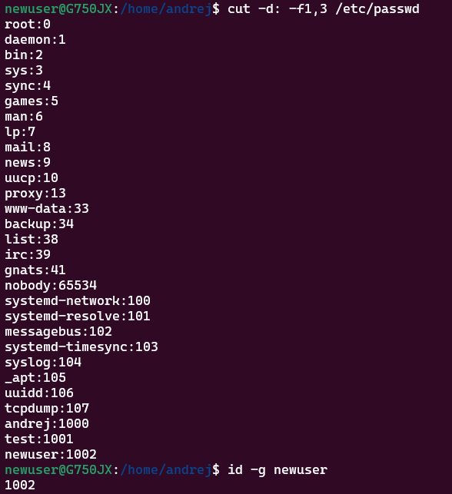
2. **id -g username** to find out the GID of the created user
3. **sudo passwd -e username** to change the password of the user and force it to change the pass on his next login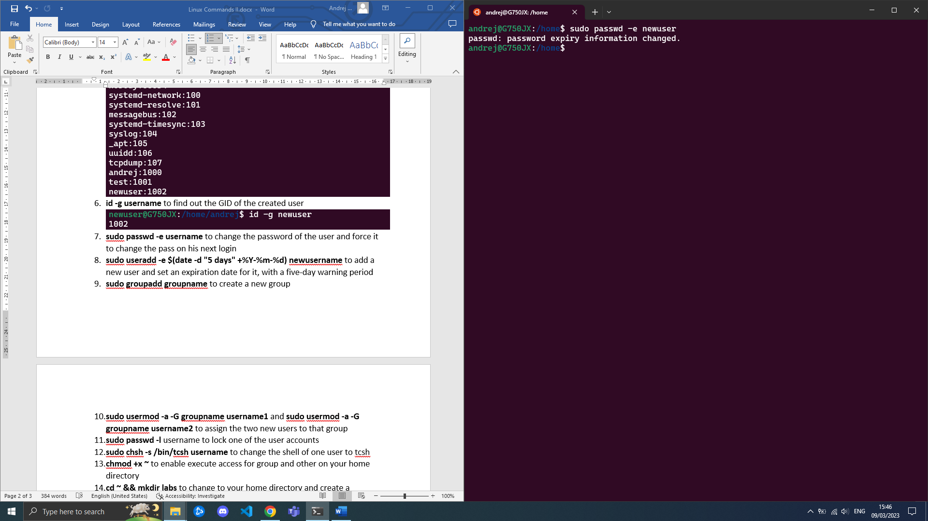
4. **sudo useradd -e $(date -d "5 days" +%Y-%m-%d) newusername** to add a new user and set an expiration date for it, with a five-day warning period

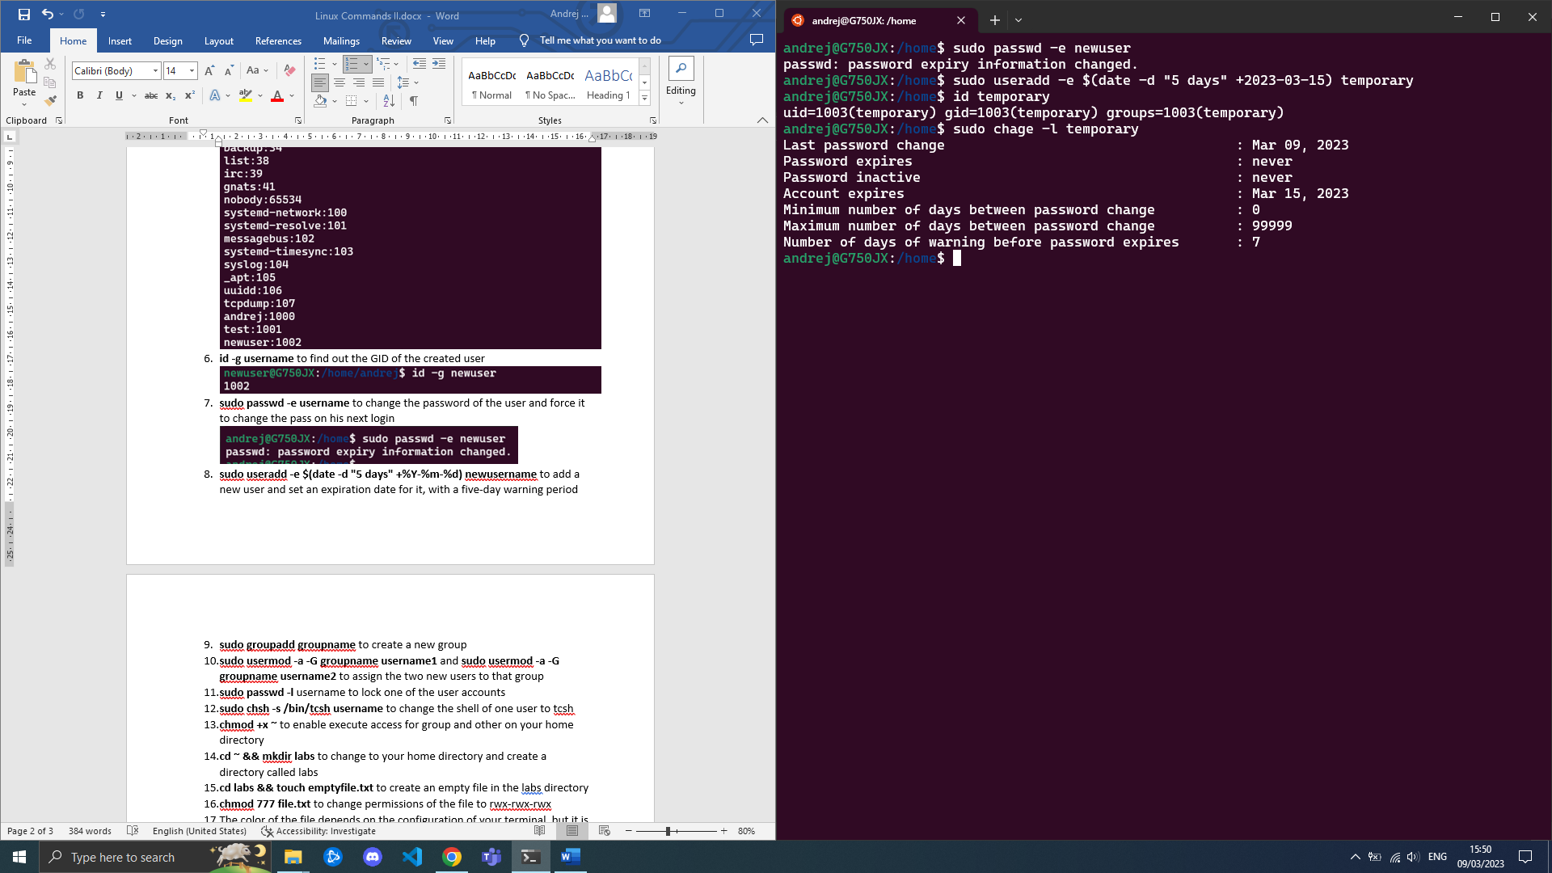

1. **sudo groupadd groupname** to create a new group

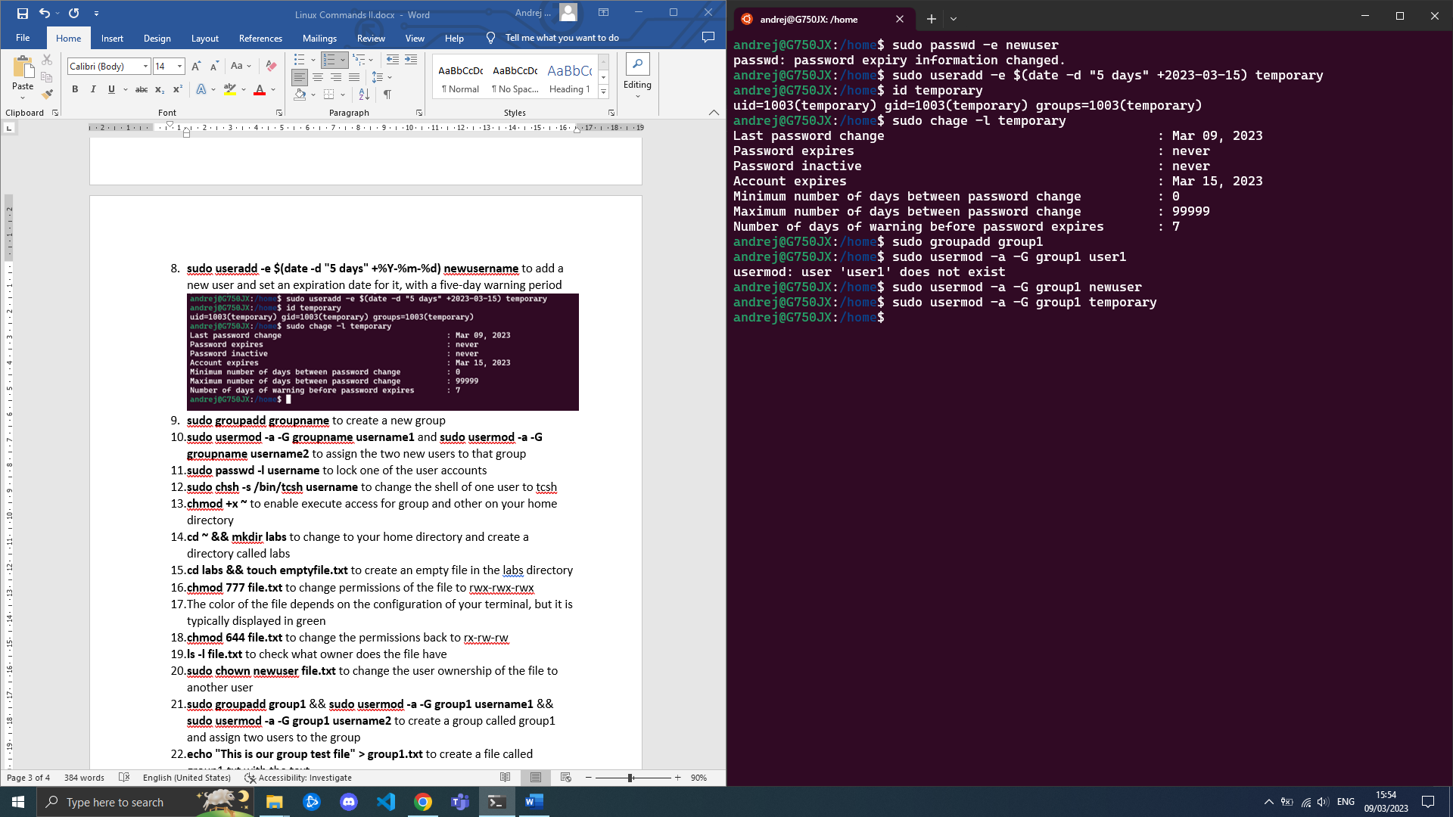

1. **sudo usermod -a -G groupname username1** and **sudo usermod -a -G groupname username2** to assign the two new users to that group



1. **sudo passwd -l username** to lock one of the user accounts

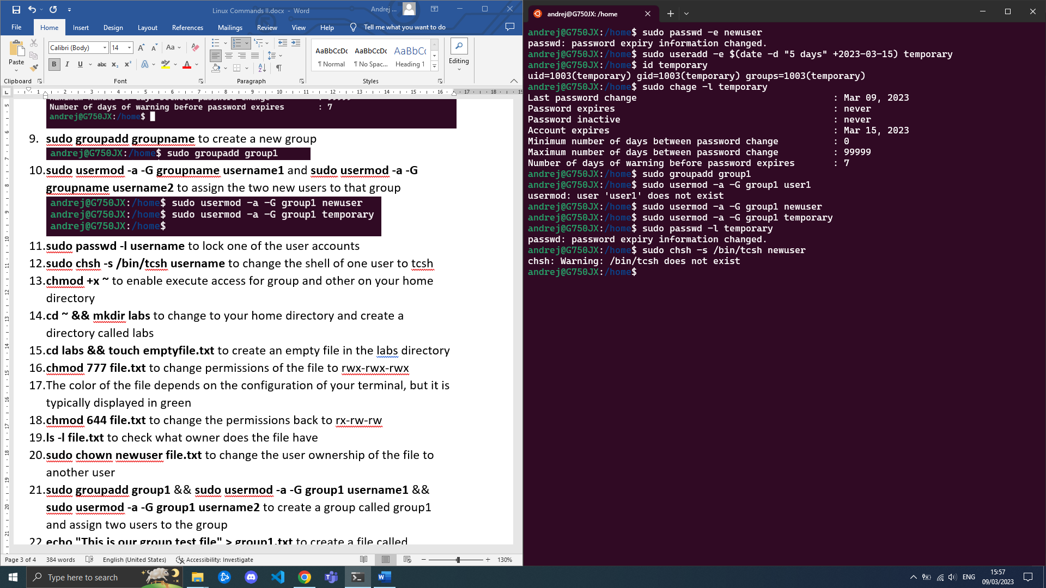

1. **sudo chsh -s /bin/tcsh username** to change the shell of one user to tcsh

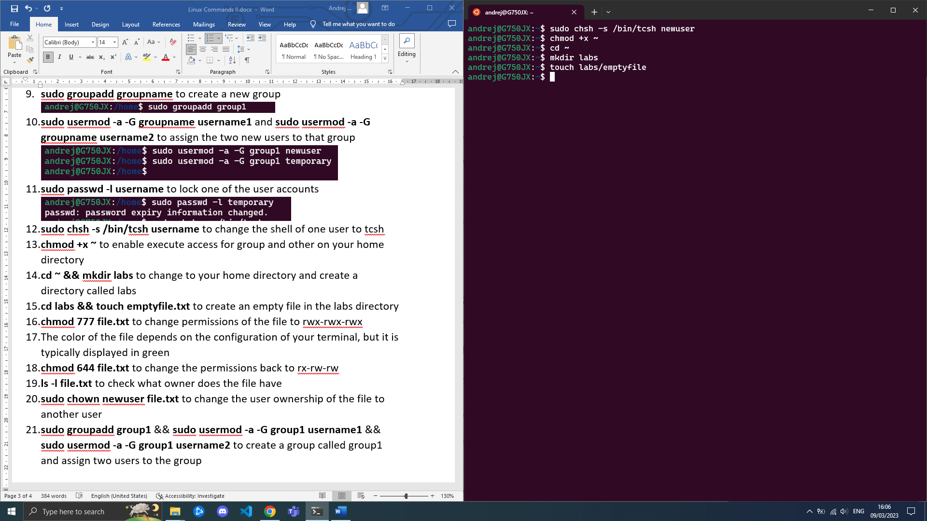

1. **chmod +x ~** to enable execute access for group and other on your home directory
2. **cd ~** and **mkdir labs** to change to home directory and create a directory called labs
3. **touch labs/emptyfile** to create an empty file in the labs directory



1. **chmod 777 emptyfile** to change permissions of the file to rwx-rwx-rwx
2. The color of the file is green.

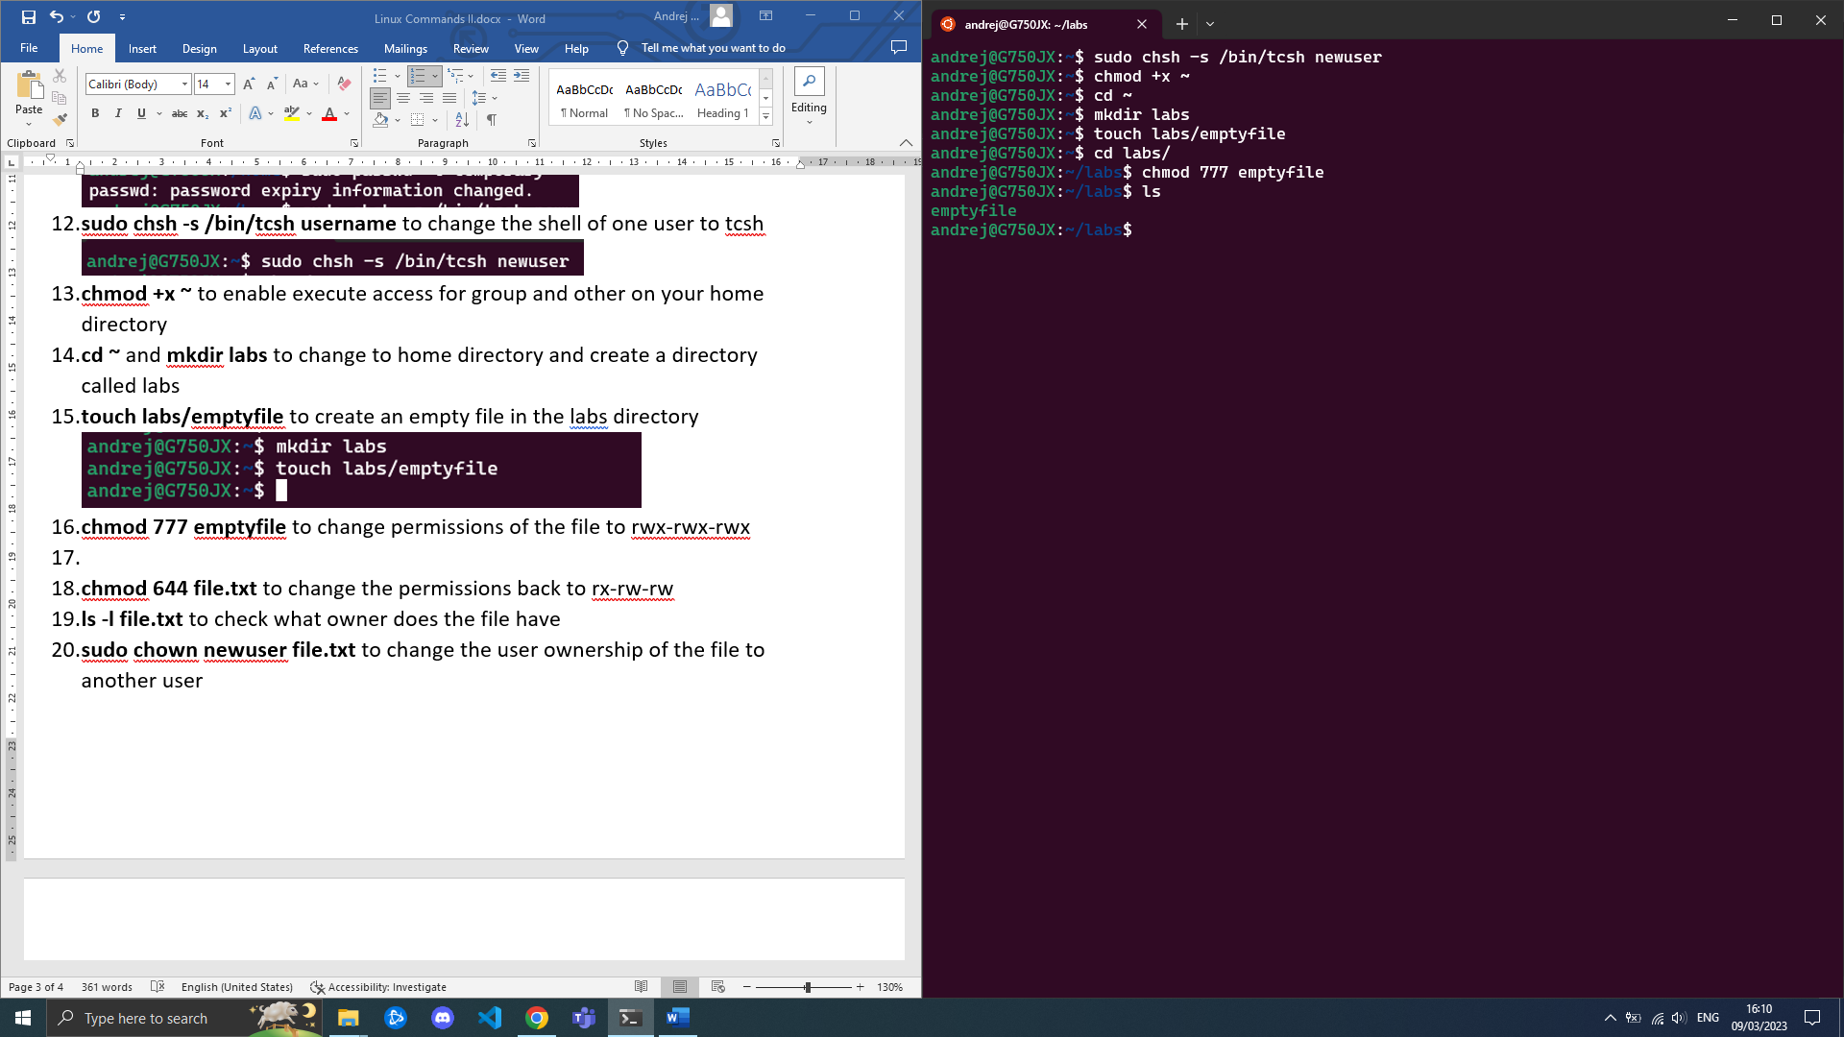

1. **chmod 566 file.txt** to change the permissions back to rx-rw-rw
2. **ls -l file.txt** to check what owner does the file have

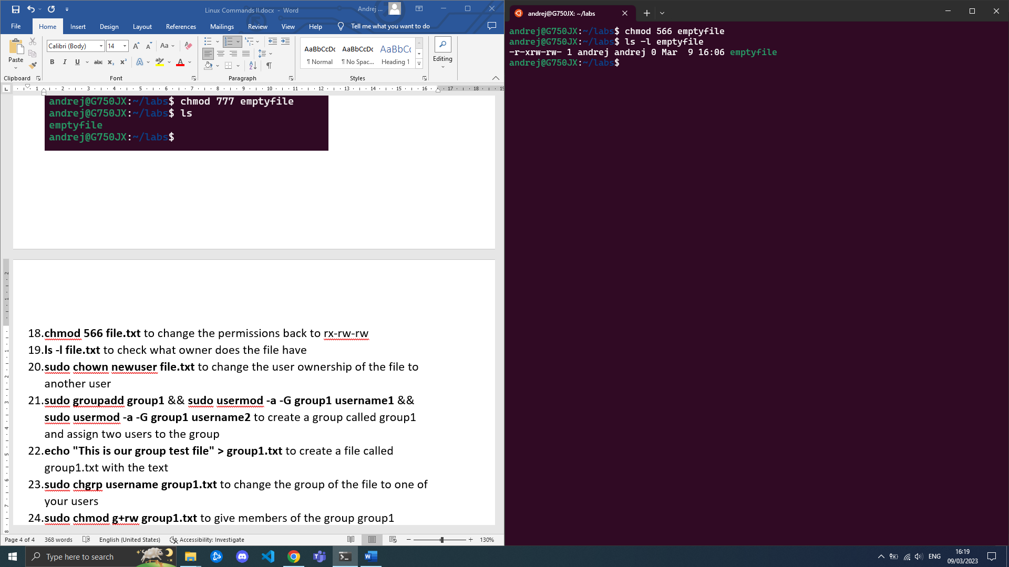

1. **sudo chown newuser file.txt** to change the user ownership of the file to another user

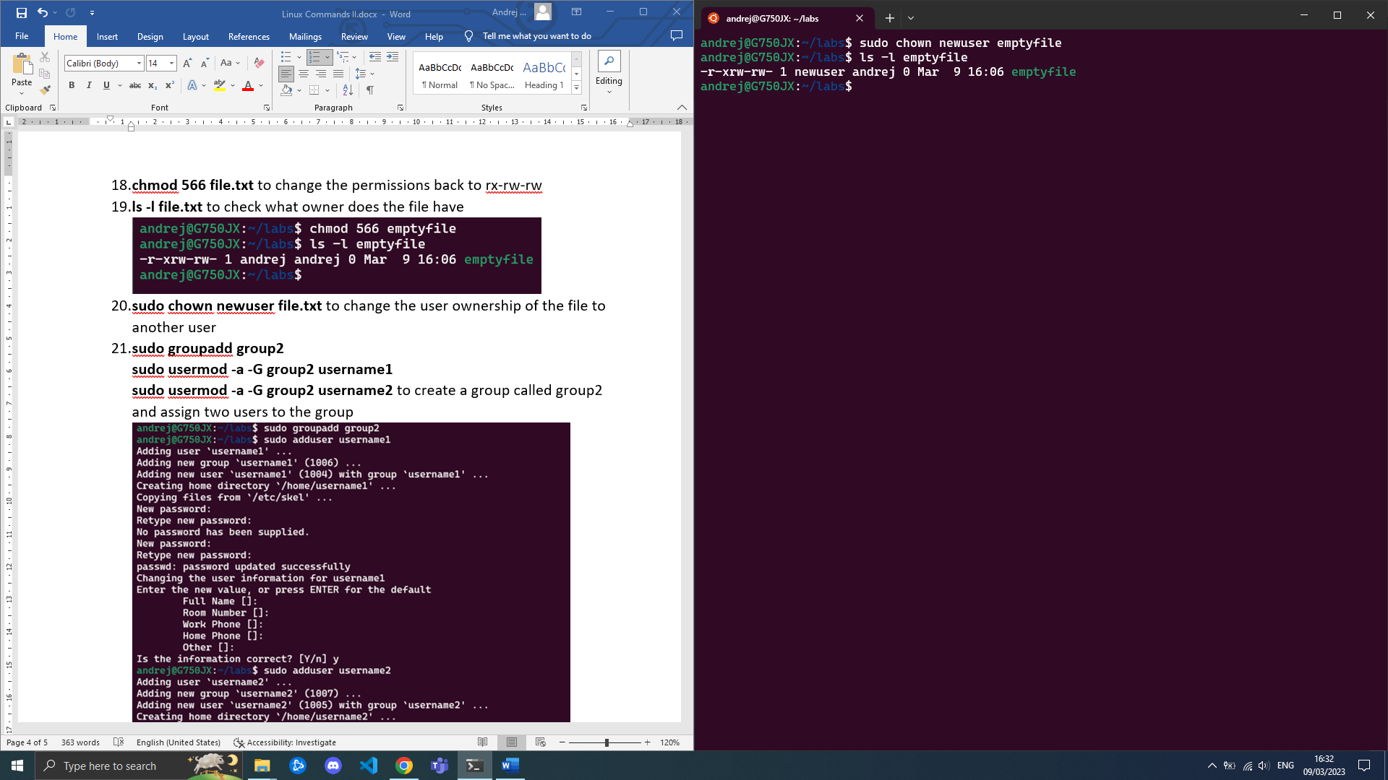

1. **sudo groupadd group2**

**sudo usermod -a -G group2 username1** **sudo usermod -a -G group2 username2** to create a group called group2 and assign two users to the group

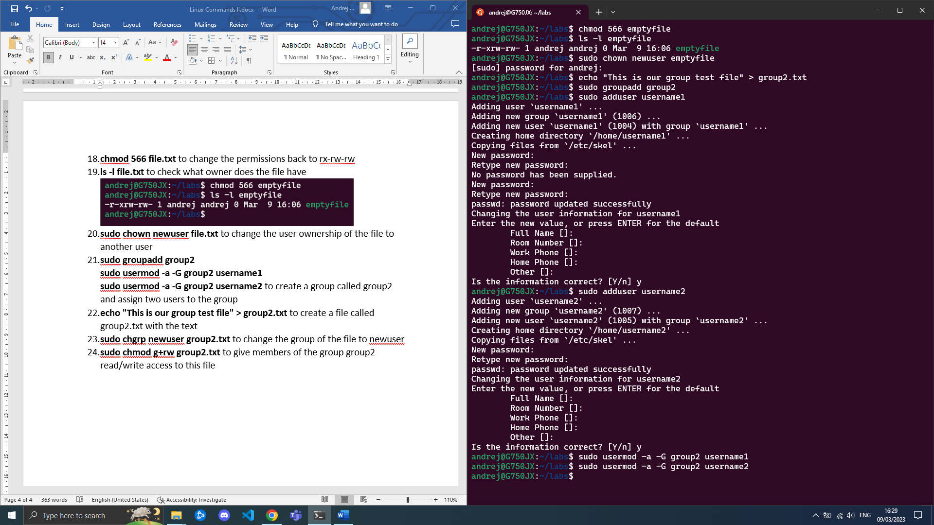

1. **echo "This is our group test file" > group2.txt** to create a file called group2.txt with the text 
2. **sudo chgrp newuser group2.txt** to change the group of the file to newuser
3. **sudo chmod g+rw group2.txt** to give members of the group group2 read/write access to this file